YUVATHARAMGAM
2015 - 2016
The Cultural and Literary committee of the college prepared the students to participate in” YuvaTarangam – 2015. The college level competitions were conducted in various events. The students of the college participated in the programmes conducted on this eve.
The Cultural and Literary committee of the college volunteers made all the necessary arrangements to conduct various programmes in the field of Cultural activities. The competitions were conducted in Mono action, one act Play, Folk Dance, Solo singing, Group singing, Rangolietc.
In the Mono action D. Mounika from the B.Sc. won the college first and She was selected to district level competitions. She participated in District level competitions held at DKW Govt College, Nellore and won the District Second Prize
In Musical Chairs – J. Aparna – II – BSc won the college first and She was selected to district level competitions. She participated in District level competitions held at DKW Govt College, Nellore and won the district first Prize and she selected to theState level competitions at Vijayawada
In One act play, the team of D.Vananja – II BSc, D. Vivek – II BSc, K. Sahan – II BSc, P. Sri Vidya – II BSc, J. Aparna – II BSc, Maheswari- I BSc the NSS volunteer won the college first and he was selected to district level competitions. The team participated in District level competitions and won the district first held at DKW Govt College, Nellore and it was selected to the State level competitions at Vijayawada.
In Group singing competition, K Amrutha, Nirosha, Eswari, Aparna won the college first and he was selected to district level competitions. The team participated in District level competitions and won the District first held at DKW Govt College, Nellore and it was selected to the State level competitions and they participated in state wide competitions at Vijayawada.
In Folk dance, the S. Durga Prasad – II BSc, P. Mallikarjuna – II BSc, Vinod – I B. Com, Kalyan – I B. Com, M. Kusuma – III BSc, V.V. Sujitha – III BSc, Amrutha – I BSc and team of the college won the college first and he was selected to district level competitions. The team participated in District level competitions held at Govt College, Gudur, Nellore and won the District first and they selected to the State level competitions. In the State level competitions conducted at ANU - Guntur they won the state third prize.
In the field of Literary area Mr. Gopinadthparticipated in the debate programme and won the college first and he was selected to district level competitions. He participated in District level competitions Govt College, Gudur, Nellore and won the District Second prize.
Mr. Gopinadth won the college first in Quiz programmes and he was selected to district level competitions. They participated in District level competitions DKW Nellore and won the District first and he was selected to the State level competitions.
.

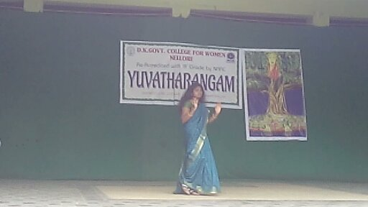
D. Mounica - Monoaction
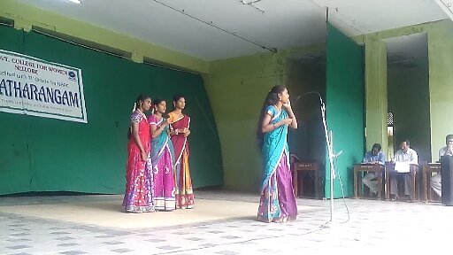
Amrutha and Group – Group Song

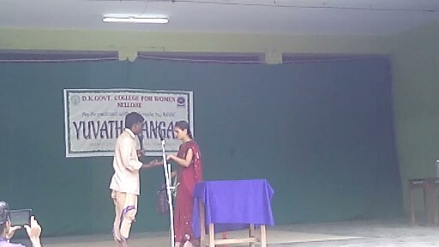
Sahan and group – One act Play

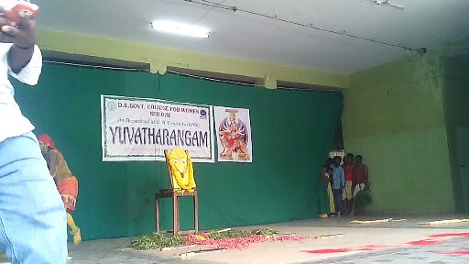
Durga Prasad and team - Folk Dance

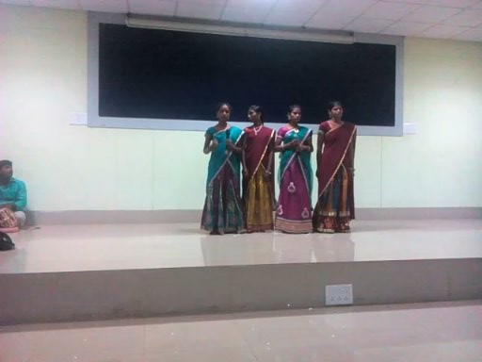
Amrutha and team – ANU Guntur ( State level competition)
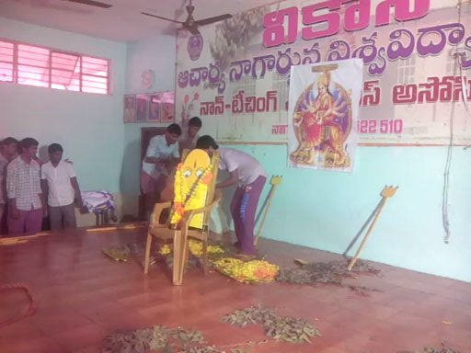
Durga Prasad and team – ANU Guntur (State level competition)

2016 - 2017

TEACHERS DAY 05-09-2016
In many countries, Teacher's Day" is intended to be special days for the appreciation of teachers and may include celebrations to honor them for their special contributions in a particular field area, or the community in general. The date on which Teachers’ Day is celebrated varies from country to country. Teachers' days are distinct from World Teachers' Day which is officially celebrated across the world on October 5.
India celebrates the birthday of Dr. Sarvepalli Radhakrishnan'sas Teachers Day on September 5 since 1962. Sarvepalli Radhakrishnan (Sarvepalli Radhakrrsnayya) (5 September 1888 – 17 April 1975) was an Indian philosopher and statesmanwho was the first Vice President of India (1952–1962) and the second President of India from 1962 to 1967
RED CROSS Volunteers made the arrangements to celebrate the Teachers Day in the college in a Grand manner. The constructed a floral art of Dr. Sarvepalli Radhakrishnanunder the guidance of Dr. Krishnamurthy, Senior faculty member, Department of English.
One of the students dressed like Dr. Sarvepalli Radhakrishnanwas participated in the celebrations
Dr. D. Giri, Principal of the college, advised the students to follow the ethics that have been followed by Dr. Sarvepalli Radhakrishnan. He appreciated the arrangements and the programme organized by the Cultural Unit of the College

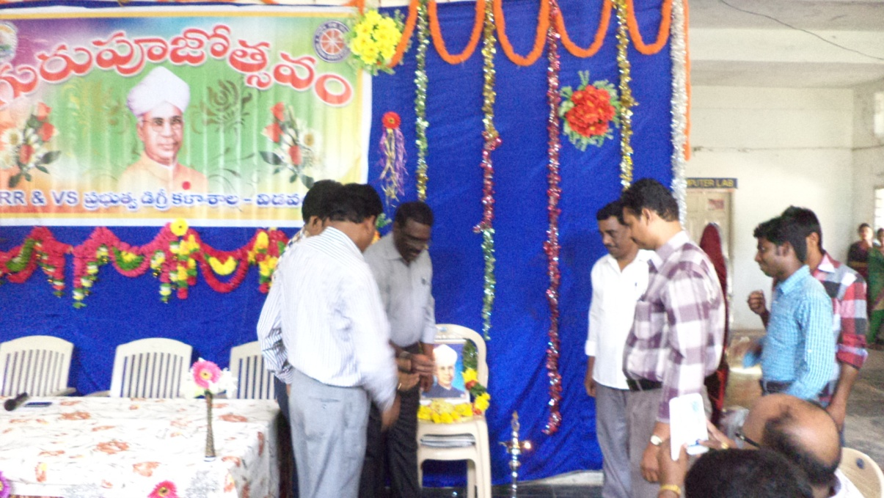

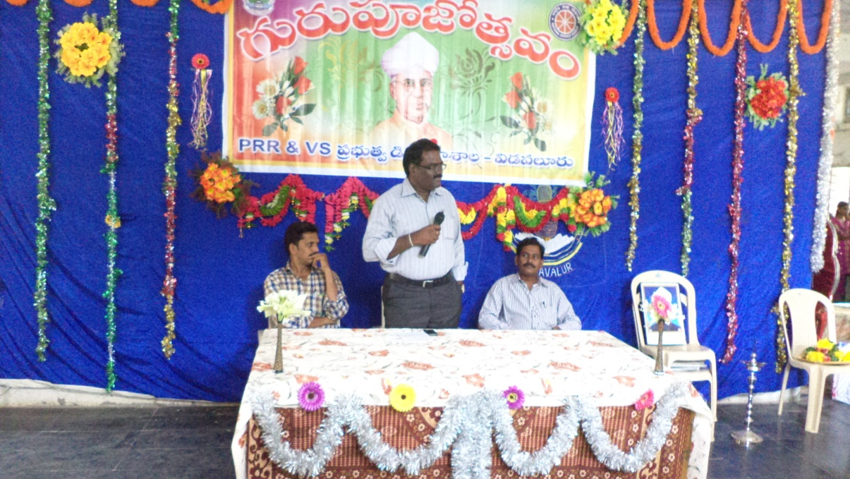

FRESHERS DAY
16-09-2016
With admission season almost over, the new collegians are gearing up for a new phase of their lives. And what better way to start college life than with a fun-filled Freshersday.
First year students of the college are eagerly awaiting their freshers' day, a kind of formal welcome by seniors and faculty members.first year students get a chance to let their hairs down and showcase the talents on freshers' day. "At our college different departments organize the day together and it's mostly about getting to know our peers, dance, music and lots of fun.
Freshers' day is also about interaction with seniors. "Though ragging is not allowed at any college, freshers' day ends all fears as we get to know our seniors. It is our official induction ceremony at college
Mr and Miss Fresher among others are also an attraction for the new students and an opportunity to make an impression on their seniors and teachers. Students leave no stones unturned to look their best and flaunt their talents.
The Cultural unit of the college made the arrangements of the freshers day function and they celebrated the day in a grand way followed by different cultural activities like skits, dance, mono-action etc. by the students of first, second and final year students

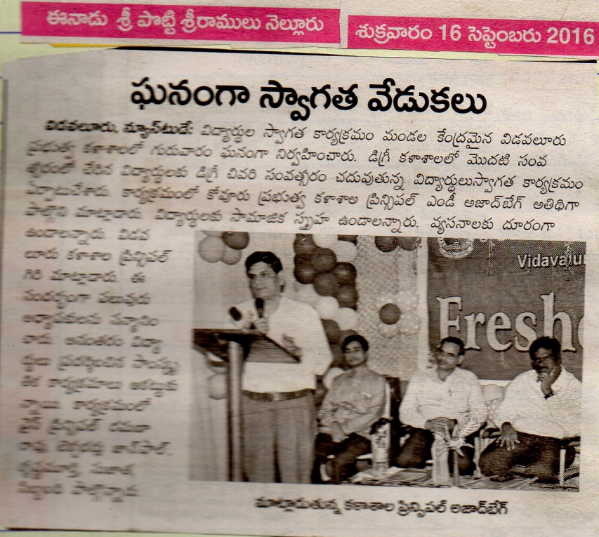

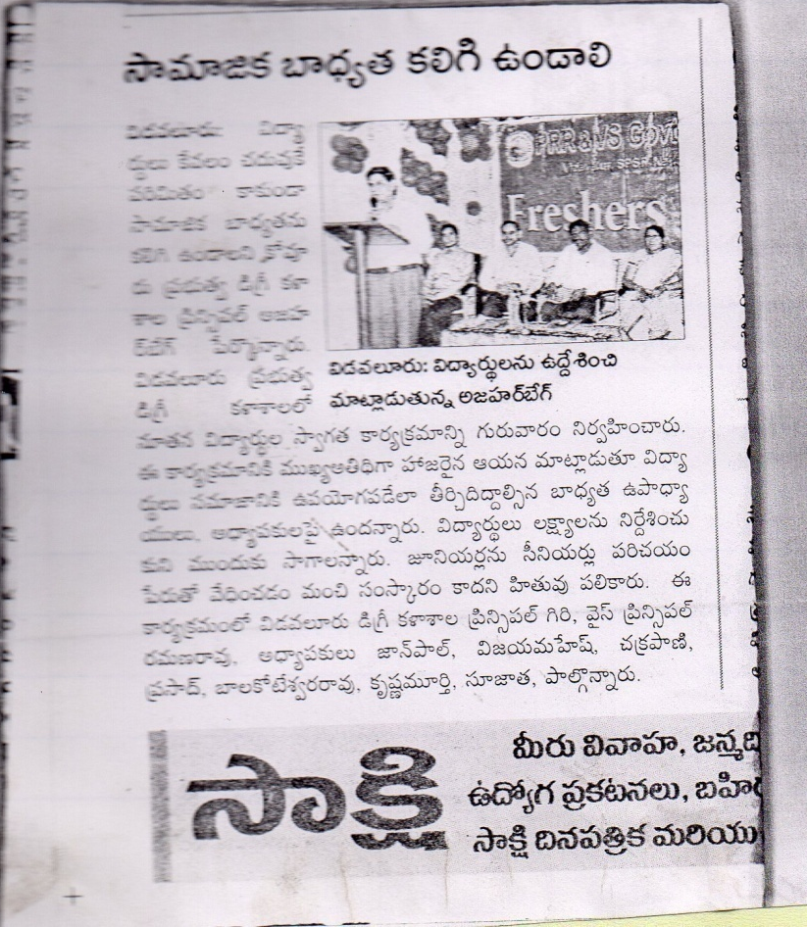

DIGITAL INDIA 21-10-2016

Digital India is a campaign launched by the Government of India to ensure that Government services are made available to citizens electronically by improving online infrastructure and by increasing Internet connectivity or by making the country digitally empowered in the field of technology.
It was launched on 1 July 2015 by Prime Minister Narendra Modi. The initiative includes plans to connect rural areas with high-speed internet networks. Digital India consists of three core components. These include:
- The creation of digital infrastructure
- Delivery of services digitally
- Digital literacy
One University level work shop was conducted in Vikrama Simhapuri university on 21/10/2016. In the workshop skits are conducted on different issues related to digital India. Our college students won the university first in the conducted skits regarding e-waste management
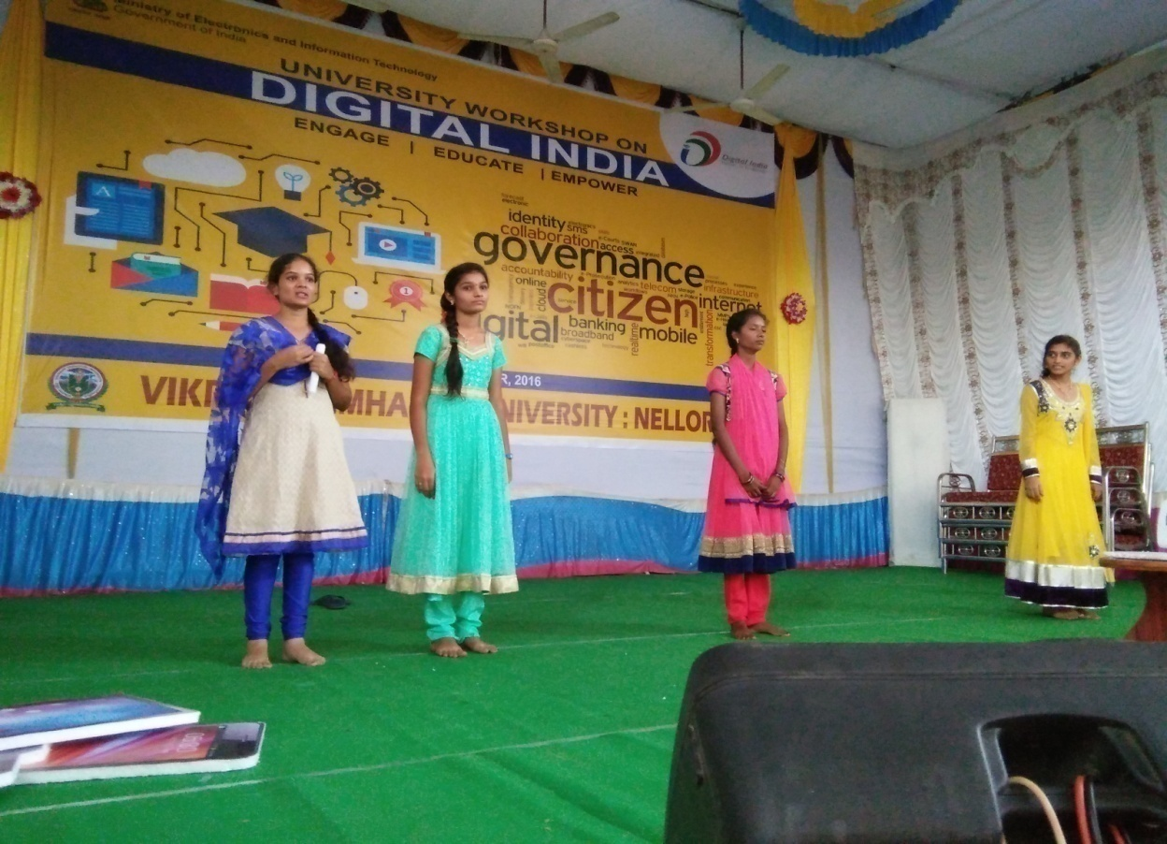
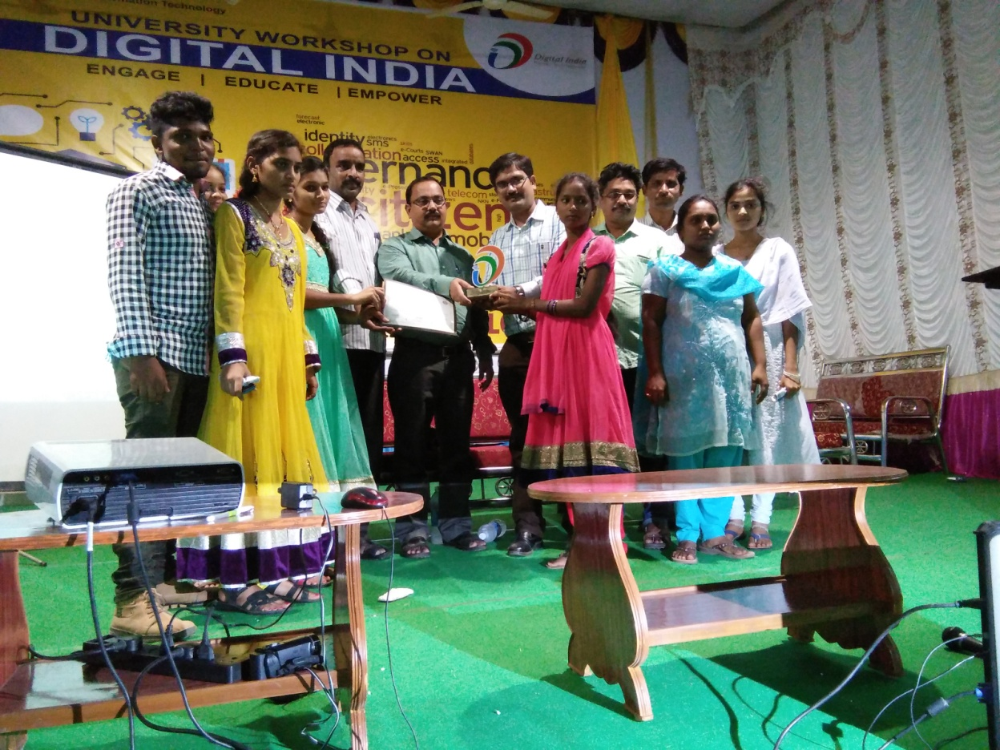

2017 - 2018

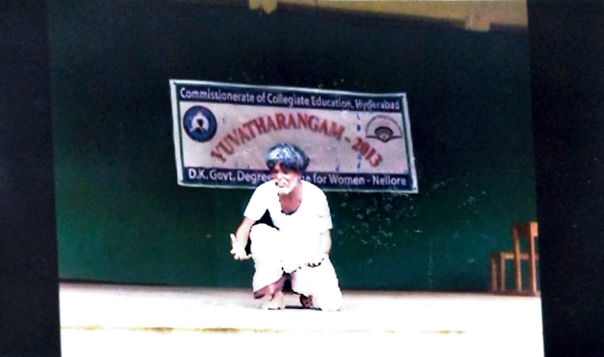

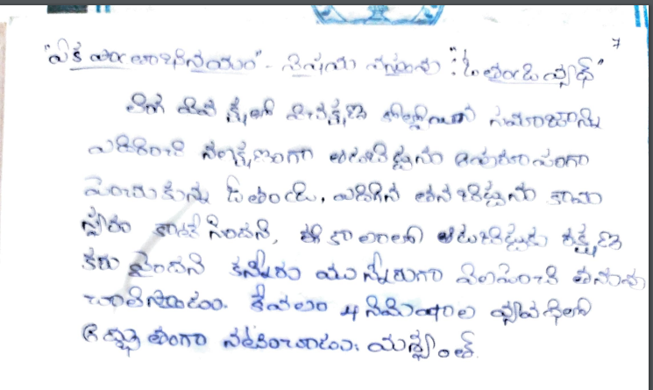

2018 – 2019

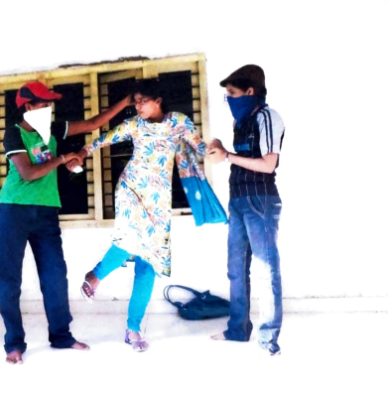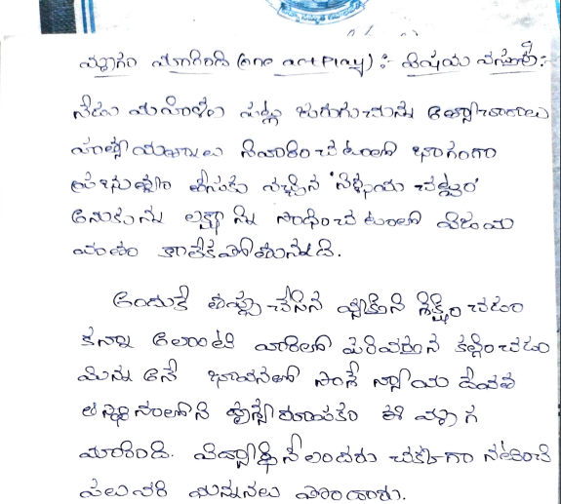

2019 – 2020

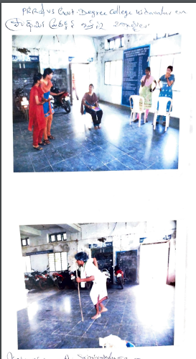

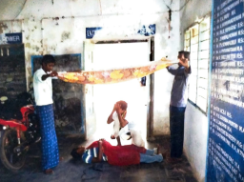
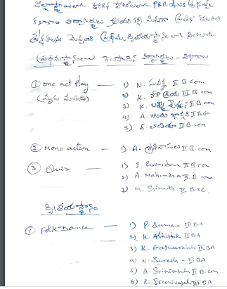

2020 – 2021

